Zhao et al., 2020 A Fast Simulation Approach to the Thermal Recovery Characteristics of Deep Borehole Heat Exchanger after Heat Extraction

The paper postulates that necessary thermal recovery after each heat extraction cycle should be properly considered to assure a DBHE’s long-term sustainable performance. It focuses on studying the thermal recovery characteristics of temperature field in the rock / around DBHE during the intermittent period.

* extend the classical finite line source model to account for the vertical heat flux distribution varying along depth (due to temperature gradient) and heterogeneous thermal conductivities in the multi-layer rock zone , based on heat source theory and superposition principle to account.
* fast simulation approach for heat transfer analysis inside the borehole coupled with the extended finite line source model is put forward to depict the transient thermal response and dynamic thermal recovery of rock outside borehole. 🡪 new algorithm for deep BHE
* simulation results show that at least 65 days of intermittence for the model in study should be spared after the heating season to achieve sustainable heat extraction in the next cyclic operation.
* simulations for thermal performance during the heating season in a three-year cyclic operation with 205 days intermittence shows that both the outflow temperature and heat extraction rate in the subsequent cycle after intermittence are in good agreement with the full 3D numerical solution in the reference
* could be applied to thermal recovery simulation after heat extraction of vertical closed loop borehole heat exchangers at arbitrary length from shallow to deep.

Actually, thermal response of DBHE under intermittent condition is a three-dimensional unsteady state heat transfer problem in essence, which varies over different time and space scales + complexity of DBHE layout/geometry (radium of mm to length of 1000m) + heat transfer problem (depend on heat extraction output in history, rock/soil-borehole interaction, ground heterogeneities, groundwater flow). “Numerical modeling appears to be a practical by accounting for complex geological effect and heat transfer process through detailed discretization schemes (i.e. OGS (Kolditz et al., 2012) or and FEFLOW (Diersch et al.,2014)) that can consider all relevant thermo-physical properties of the BHE and capture the physical parameters of the borefield in high detail. But high computational cost + mesh needs to be created manually under the framework of the fully discretized models which prohibits fast simulations.”

Here, a simulation tool has to be developed that satisfies the following requirements: high physical detail of the model at acceptable computational speed, which is more applicable for the design and optimization problems that require iterative calculations.

Literature has highly considered modeling and simulation of heat transfer characteristics of DBHE + investigation on its thermal performance under operating.

* Wang et al.: numerical investigation on the heat transfer characteristics and optimal design of the heat exchangers of a deep borehole ground source heat pump system, but only continuous condition without intermittent state simulation.
* Chen and Shao et al. implemented a FEM numerical model in OGS for the performance analysis of the DBHE.
* Kong et al. used FEM to demonstrate the feasibility of long-term and short-term operations of DBHE by considering the effects of geothermal gradients.
* Ma proposed a heat transfer analytical model for downhole coaxial heat exchangers and showed that heat transfer of DBHE could be improved by increasing the Reynolds number
* Fang et al. developed a computational efficient method for thermal analysis by FDM, validated by the reference data using FEM. However, the dynamic heat propagation front for thermal affecting radius evolution with time in the radial direction was not analyzed physically, and the thermal response was only simulated through the given annual load profile, and the intermittent condition was not studied.

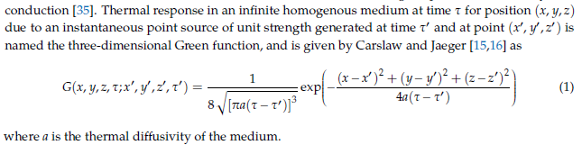

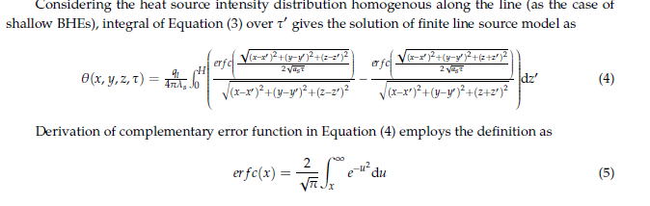 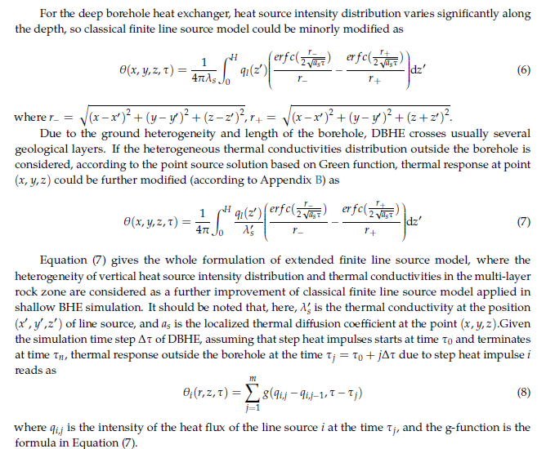

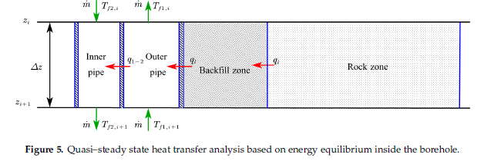

FLSM –> transient thermal response outside BH 🡪 Quasi steady state model --> Heat flux distribution in BH

Thermal performance of DBHE described by the input operation parameters (flow rate or inlet temperature) + transient rock or soil temperature distribution outside the borehole + continuous/transient operation.

🡪 Existence of a swift change on heat flux distribution along the DBHE during recovery period when DBHE operates discontinuously

🡪 Radial heat conduction dominates during operation VS vertical heat flux during recovery. Physical modeling for transient thermal affecting zone in the rock and heat flux distribution along the borehole in reference [34] is valid for operating condition not for the simulation of thermal recovery outside the borehole under the intermittent state. Thus, a proper approach to simulate thermal recovery, essential for operational strategy implementation has been developed (to determine how many days are required to enable sufficient recovery after heat extraction and allow sustainable production).

* Study shows that given sufficient time for thermal recovery after heat extraction, coldness accumulation near the borehole eliminated, and rock temperature recovers almost to its initial undisturbed state (not affect potential of subsequent heat extraction in the following years)
* fast recovery stage at the initial intermittence when coldness due to heat extraction diffuses away, then the recovery speed slows down gradually
* No temperature decline in the deepest rock, as a bottom boundary (What is it ???) so heat extracted from radial direction contributes more to thermal recovery than vertical heat conduction from deep rock.

BUT (personal notes)

* Does not consider groundwater flow in the analytical solution equation
* Does not evaluate the share from each sources on the total recharge + the influence of different properties on the recharge rate?
* Zero heat flux boundary is set below the constant temperature layer without consideration of the variable temperature zone due to atmosphere influence for simplicity of simulation. + temperature gradient as far field boundary in the radial direction along the depth (IC) + isothermal boundary at bottom DBHE.